Arma/ Arima test
- Check for which test to use
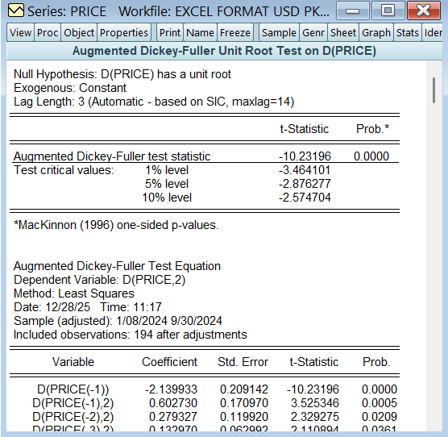
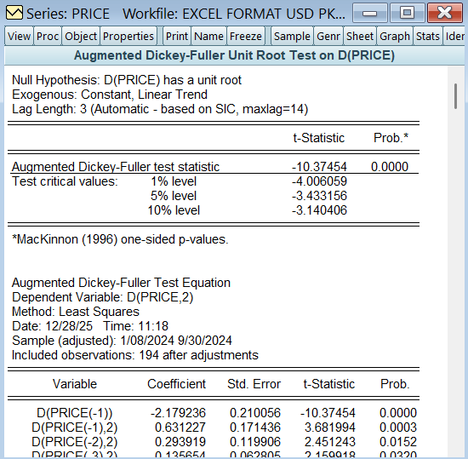

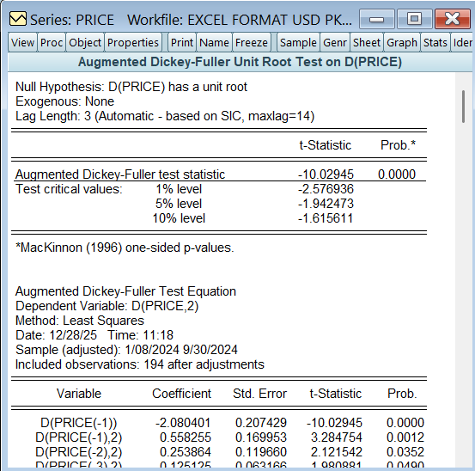

Conclusion
As values are not stationary at level so we moved towards 1st difference and Arima model for our prediction
- Now lets check which model of Arima to use
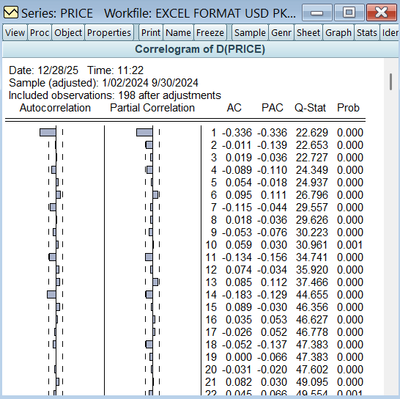
Models selected:
Arima(1,1,1)
Arima(1,1,0)
Arima(0,1,1)
- Lets now compare these 3 models:
Model | sig | Sigma Sq | R^2 | Akaike
Arima(1,1,1) | 0 | 0 | 1 | 1 | 1
Arima(1,1,0) | 1 | 1 | 0 | 0 | 0
Arima(0,1,1) | 1 | 1 | 1 | 1 | 1
From this we can clearly see that Arima (0,1,1) is the clear winner.
Attaching pictures in the same sequence
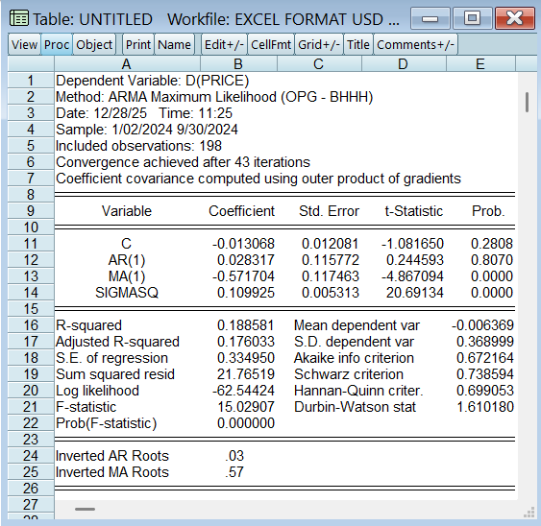
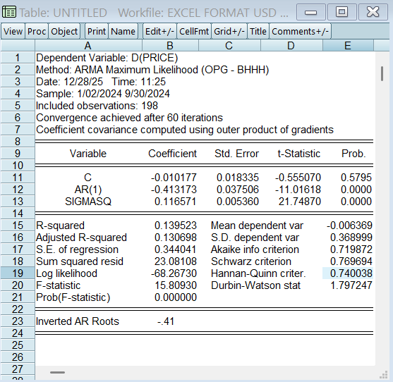
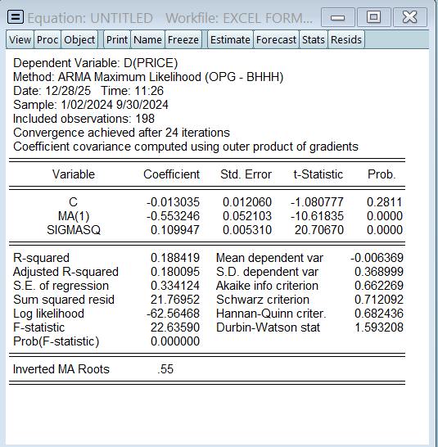

Now lets do unit root test of residuals
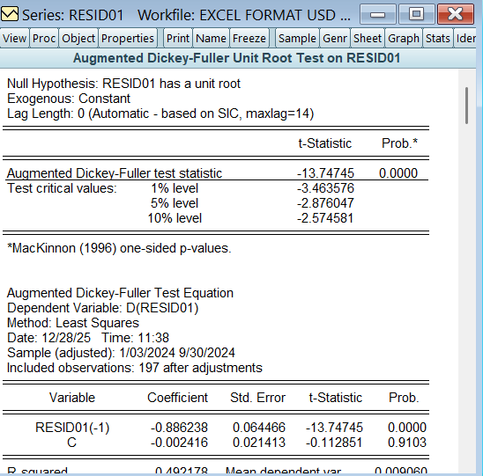
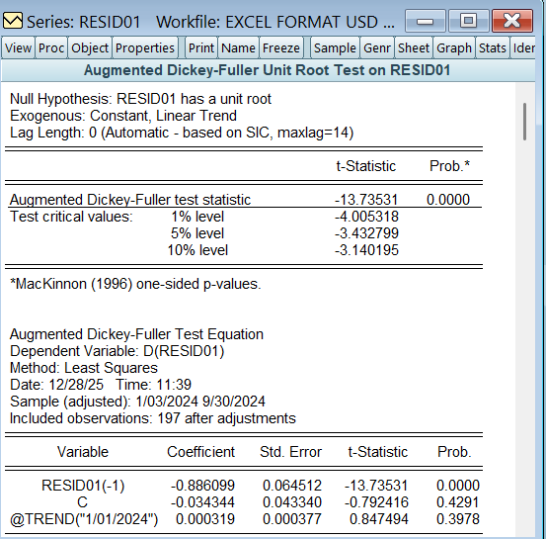
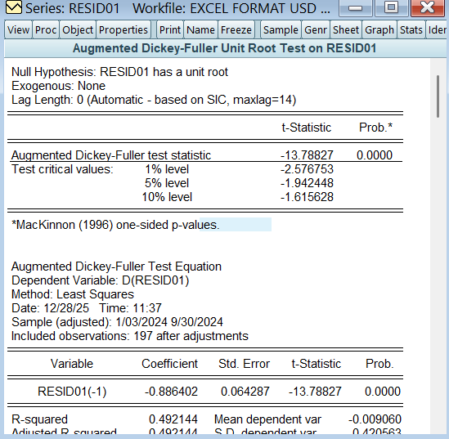

Now lets see the correlogram at level
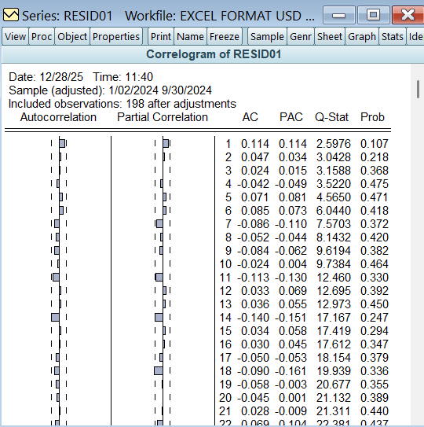

Here we have the forecasted price:
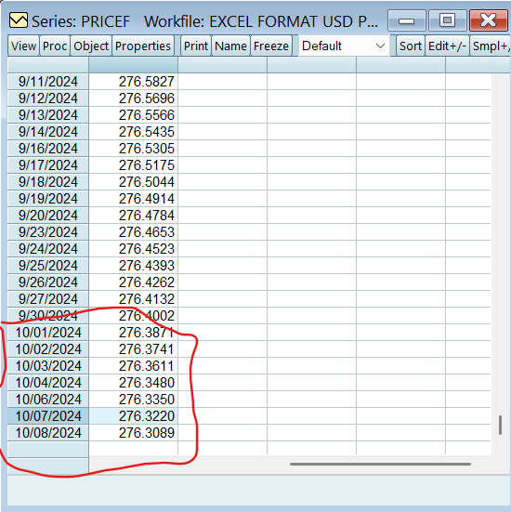
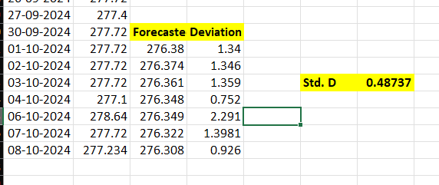

Our forcast has the standard deviation of 49 paisas

